Geometry: Unit 7, Lesson 6
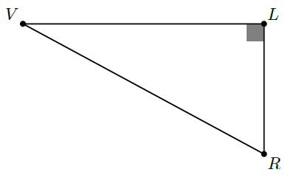
- Right triangle $VLR$ is shown where $m∠RVL=30°$, $m∠VLR=90°$, and $LR=2.7$. What is $m∠VRL$?

$$60°$$

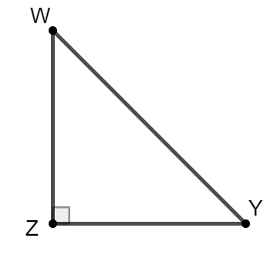
- Right triangle $WYZ$ is shown, where $m∠WZY=90°$, $m∠YWZ=45°$, and $ZW=4.5$. What is the length of $\overline{ZY}$?

$$4.5$$

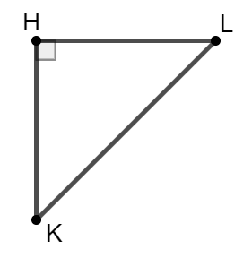
- Right triangle $LHK$ is shown where $m∠LHK=90°$, $m∠HKL=45°$, $HL=HK=6$. Is the statement $6^{2}+6^{2}=KL^{2}$ true?

Yes

